Assignment 2: Evaluation, Neural Networks, and Sequential Models
Total Marks: 100

Instructions: Please answer the following questions based on the lecture materials from Weeks 4, 5, and 6. Your answers should be clear, concise, and demonstrate your understanding of the core concepts, architectures, and strategic considerations discussed.

Part 1: Week 4 - Model Evaluation & Improvement (35 Marks)
1. Choosing the Right Metric (20 Marks) For each scenario below, an AI model is being evaluated. Your task is to identify the most critical evaluation metric (Accuracy, Precision, or Recall) and justify your choice by explaining the costs of the different types of errors.

- a) Autonomous Vehicle Pedestrian Detection: An AI system in a self-driving car designed to detect pedestrians and trigger emergency braking.
- b) Email Spam Filtering: An AI that decides whether an incoming email is spam or a legitimate message ("ham").

2. Diagnosing Overfitting with Learning Curves (15 Marks) An engineer shows you the following learning curve plot for their new AI model. The blue line represents the model's error on the training data, and the orange line represents its error on the validation data.

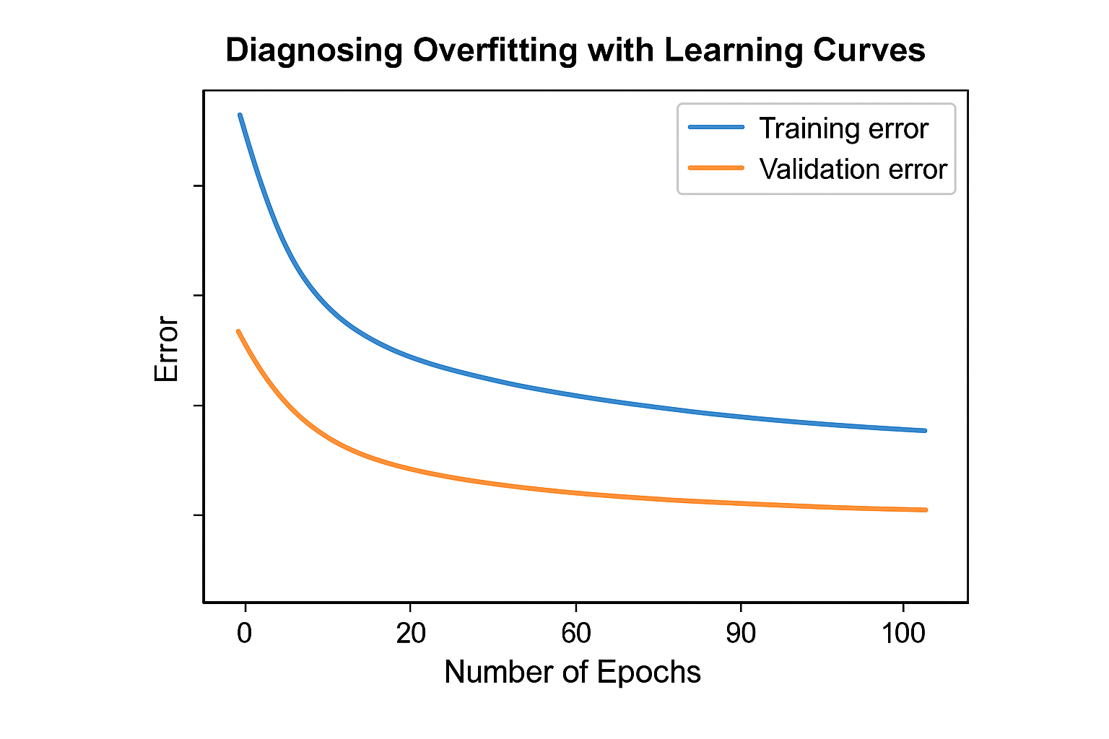

Based on this hypothetical chart, is the model suffering from underfitting, overfitting, or is it a well-fit model? Justify your answer by explaining what the significant gap between the blue and orange lines indicates about the model's performance.

Part 2: Week 5 - Neural Networks & Deep Learning (35 Marks)
3. The Power of CNNs for Image Processing (20 Marks) Traditional fully-connected neural networks are generally not used for image recognition tasks. Convolutional Neural Networks (CNNs) are much more effective.

- a) Describe two key architectural features of CNNs (e.g., local connectivity, weight sharing) that make them uniquely suited for processing images.
- b) What is the purpose of a pooling layer (e.g., max pooling) in a CNN?

4. Transfer Learning Strategy (15 Marks) You are tasked with building an AI model to classify different types of skin cancer from a limited dataset of only 2,000 medical images. Training a deep neural network from scratch would be very difficult with so little data.

Explain the concept of transfer learning and how you would apply it to this problem. What kind of pre-trained model would you use, and what parts of that model would you modify or retrain?

Part 3: Week 6 - Advanced Neural Networks (30 Marks)
5. Feedforward vs. Recurrent Neural Networks (15 Marks) What is the fundamental architectural difference between a standard feedforward neural network (like those from Week 5) and a Recurrent Neural Network (RNN)? Explain why this difference makes RNNs suitable for tasks like language translation or stock price prediction, where feedforward networks would fail.

6. The Vanishing Gradient Problem (15 Marks) In simple RNNs, the vanishing gradient problem makes it difficult for the network to learn from information that appeared early in a long sequence. Explain this problem using an analogy (like the "game of telephone" from the lecture) and name one of the advanced architectures (like LSTM or GRU) designed to solve it.

